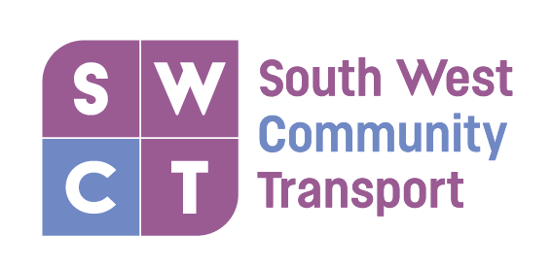
We Bring Unity to Community
Patient Transport Service

Conditions of Service

- Our service is for appointments between 9am and 4pm, however, the service may be provided outwith these hours if a volunteer driver is available.

- Appointments can be made by phoning 0141 881 9998 or send an email to manager@southwestct.org.uk

- All appointments are subject to the availability of a volunteer driver and no appointments are guaranteed.

- The office must be notified of appointments at least 7 days in advance of the appointment.

- The office must be notified of any changes/cancellations or if you are no longer able to attend your appointment at the earliest opportunity.

- Volunteer drivers can assist patients in and out of the vehicle, however; patients must be able to walk by themselves or transfer from the vehicle to a wheelchair with minimal assistance.

- Failure to meet these conditions, may result in you being removed from the service.

- Abuse towards volunteers or staff, or abuse of the service will result in you being removed from the service.

